Information Dialog

Selecting File → Info... invokes the Information Dialog for the currently loaded dataset or from the corresponding toolbar button.

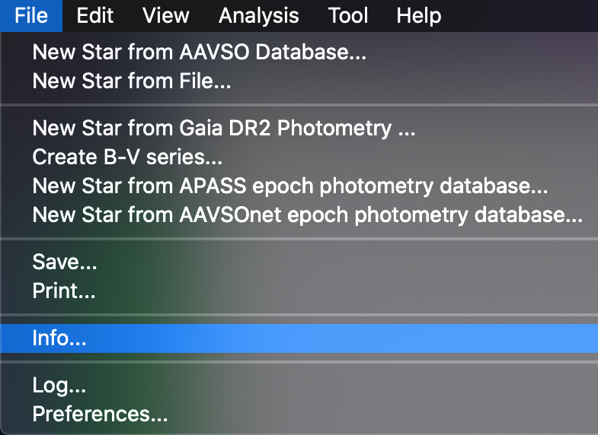
Here is an example Information Dialog for 2 years of R Car data:

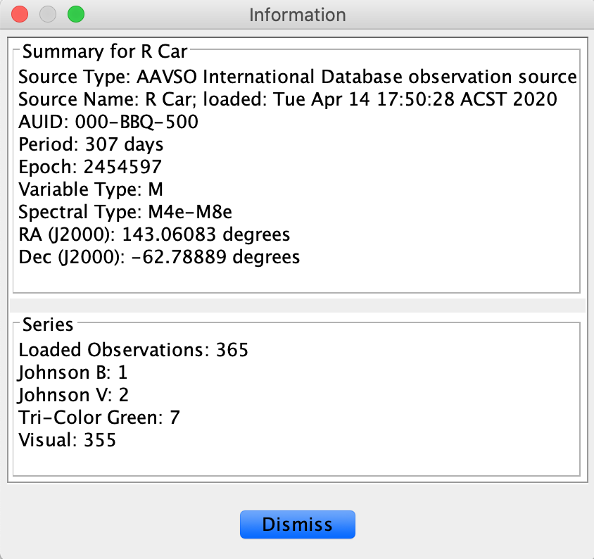
The dialog is divided into Summary and Series sections.

The Summary section includes information about the source of the dataset, AAVSO Unique ID (AUID), and if known, period, epoch, variable type, spectral type, and coordinates. For an AID loaded dataset like this VSX is consulted for such information.

For an observation source other than AID (e.g. AAVSO upload or download files, ASAS, Kepler), VSX is not consulted so the summary information will be different. Here is an example of an Information Dialog for ASAS R Car data:

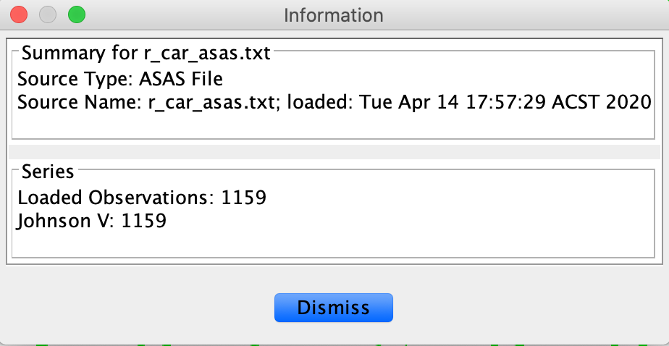
The Series section lists all series present in the dataset (e.g. the filter band or visual observations) along with the number of observations in each series.

